Jukify Progress Statement – Increment 3

# Progress description

## Frontend app

* Further functionality added
  + Join party
  + Search song
  + Add song
  + Ein Bild, das Text, Screenshot, Monitor, Bildschirm enthält.

    Automatisch generierte BeschreibungQR Codes

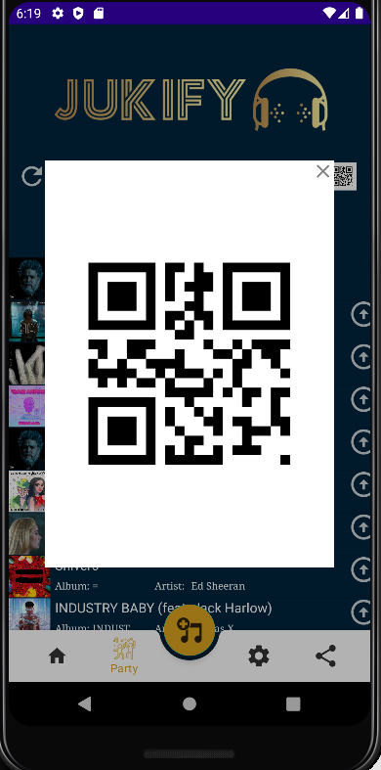

* UI Testing through usage of Python click simulator

Ein Bild, das Text, Elektronik, Screenshot enthält.

### Next Steps

* Further functionality (party history, refresh view of the queue)
* Documentation

## Backend

* New calls implemented
  + Includes /getQueueList, /frontendTest (for HTTPClient Unit testing, frontend side)
* Unit tests developed
* Queue linked list data structure

### Next Steps

* Documentation